Deeper Networks for Image Classification

Abstract—This report presents a comprehensive study on the effectiveness of deeper neural network architectures, VGG16 and GoogLeNet, for image classification tasks using the MNIST and CIFAR-10 datasets. The investigation explores the models' capabilities in learning discriminative features from diverse image datasets, encompassing grayscale handwritten digits in MNIST and color images of various objects in CIFAR-10. The study evaluates the models' performance metrics through rigorous experimentation and analysis, including accuracy, convergence behavior, and generalization across different datasets. Results showcase the robustness of VGG16 and GoogLeNet architectures in achieving high accuracy on both MNIST and CIFAR-10 datasets, shedding light on their adaptability to diverse image types and complexities.

I. INTRODUCTION
This paper compares two prominent Convolutional Neural Network (CNN) models, GoogLeNet and VGG-16, evaluated on two widely-used datasets: MNIST and CIFAR-10. The study aims to assess the performance and efficacy of these models in image classification tasks. Each chapter provides insights into the models' architectures, experimental methodologies, findings, and discussions. The

conclusion synthesizes the key findings and suggests potential avenues for future research in CNN-based image classification.

II. LITERATURE REVIEW

A. Neural Network models
- GoogLeNet: GoogleNet, also known as Inception V1, emerged as the winner of the ILSVRC 2014 image classification challenge, demonstrating a significant reduction in error rates compared to previous champions like AlexNet and ZF-Net. Proposed in the research paper "Going Deeper with Convolutions," GoogleNet introduced several innovative features, including 1×1 convolutions and global average pooling, enabling the creation of deeper architectures. By strategically incorporating 1×1 convolutions, GoogleNet effectively reduced the number of parameters while increasing the depth of the architecture, enhancing computational efficiency. The utilization of global average pooling at the end of the network further streamlined computation and improved accuracy. Additionally, GoogleNet introduced the inception module, which integrates 1×1, 3×3, and 5×5 convolutions and 3×3 max pooling in a parallel manner, facilitating multi-scale feature extraction. Moreover, the architecture incorporates auxiliary classifiers for training, aiding in combating gradient vanishing and providing regularization. These innovations collectively contributed to GoogleNet's success and established it as a seminal model in convolutional neural network (CNN) architecture for image classification tasks.

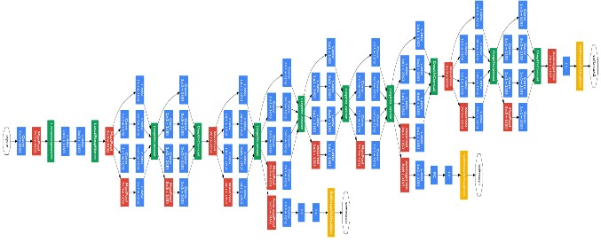
Fig. 1: GoogleNet Architecture
- VGG-16: VGG16, a convolutional neural network (CNN) model proposed by K. Simonyan and A. Zisserman from Oxford University, stands as a milestone in image recognition. Published in "Very Deep Convolutional Networks for LargeScale Image Recognition," VGG16 supports 16 layers and achieved remarkable test accuracy of 92.7% in ImageNet, a dataset with over 14 million training images across 1000 object classes, making it a top performer in the ILSVRC2014 competition. Improving upon AlexNet, VGG16 replaces large filters with sequences of smaller 3×3 filters, enhancing efficiency and reducing overfitting during training. The architecture's simplicity, utilizing small convolutional filters and ReLU activations, contributes to its success. With 138 million parameters, VGG16 remains one of the most influential models in CNN architecture, offering insights into feature learning and spatial understanding in image classification tasks.

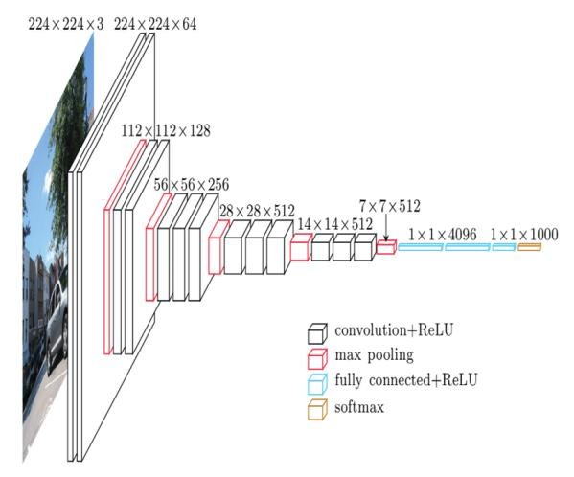
Fig 2: VGG-16

B. Image datasets

- MNIST: The MNIST dataset, an abbreviation for Modified National Institute of Standards and Technology, stands as a cornerstone in the realm of machine learning for image classification tasks. Comprising 70,000 grayscale images, each measuring 28x28 pixels, MNIST is divided into 60,000 training images and 10,000 test images. These images portray handwritten digits ranging from 0 to 9, providing a diverse array of examples for training and evaluating classification models. Each image is accompanied by a corresponding label denoting the digit it represents, enabling supervised learning approaches to effectively train classifiers. Examples of the classes can be seen in Figure 3.
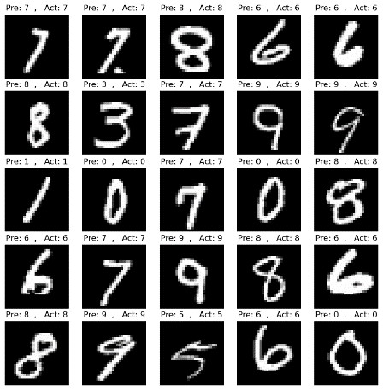
Fig 3: MNIST image samples

- Cifar10: The CIFAR-10 dataset, originating from the Canadian Institute for Advanced Research, is a pivotal benchmark dataset in computer vision and machine learning. Comprising 10 classes of 32x32 color images, each containing 6,000 samples. With 50,000 training images and 10,000 test images evenly distributed across classes, CIFAR-10 poses a challenging task for image classification algorithms due to its low resolution and small image size. Despite its compact size, CIFAR-10 serves as a vital resource for evaluating the robustness and generalization capability of image classification models, driving innovation and research in computer vision and machine learning domains. Its popularity stems from its ability to simulate real-world image classification scenarios while providing a manageable dataset size, making it indispensable for advancing the field's understanding and development.
Examples of the classes can be seen in Figure 4.

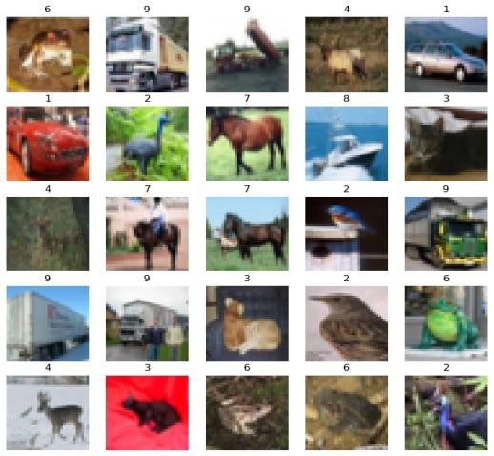
Fig 4. CIFAR image samples

III. METHODOLOGY
In the first subsection III-A the implementation of the models using the framework Keras will be explained. In the subsection, III-B involves training and compilation and in III-C, it will be explained how the datasets have been made compatible with the models.
A. Model implementation The MNIST dataset is loaded using mnist. load_data () from TensorFlow Keras datasets for both the models.
The input images are preprocessed by normalizing pixel values to the range [0, 1] and expanding the dimensions to match the expected input shape for each model.

1) VGG-16:
Defining the VGG Model:
The create_vgg_model() function constructs the VGG model architecture using TensorFlow Keras layers.
It consists of several convolutional layers with 3x3 filters, ReLU activation, and 'same' padding to maintain spatial dimensions. Max-pooling layers are added after every two convolutional layers to reduce spatial dimensions.
The model architecture adheres to the VGG-like design principles, which emphasize stacking multiple convolutional layers to increase model depth.

2) GoogLeNet:
- Defining the Inception Module: The InceptionModule class defines a custom layer representing an Inception module. It contains multiple convolutional branches with different filter sizes and pooling operations.
Each branch performs a convolution operation with different filter sizes (1x1, 3x3, 5x5) and/or pooling.
The outputs of these branches are concatenated along the channel dimension to form the module's output.

- Defining the GoogleNet Model:
The create_googlenet_model() function constructs the GoogleNet architecture using TensorFlow Keras layers.
It starts with a series of convolutional and maxpooling layers to extract features from the input images.
Multiple Inception modules are then stacked to capture features at different scales and complexities.
The model gradually increases the number of filters and complexity as it goes deeper through the network.
Global average pooling is applied to reduce the spatial dimensions of the feature maps to a vector of fixed length.
Finally, a dense layer with softmax activation is added to produce the final classification output for the 10 classes in the MNIST dataset.

B. Training
The training process for both the VGG model and the GoogleNet (Inception V1) model involves two main steps: compilation and training. During compilation, the models are configured with the Adam optimizer and categorical cross-entropy loss function to optimize their performance. Training is then initiated using the fit() method, where the models iteratively adjust their parameters to minimize the loss function while processing the training dataset in batches. The number of epochs, set to 30, determines how many times the models iterate over the dataset, while a batch size of 128 dictates the number of samples processed before updating the parameters. Validation data are used to monitor the models' performance on unseen data and detect overfitting. Throughout the training, the models refine their parameters to improve accuracy and generalization on both the training and validation datasets, with further optimization possible by adjusting hyperparameters like learning rate and batch size.

C. The Datasets
The datasets used in this paper both have a resolution of 28x28 pixels. On top, the Cifar10 dataset has three color channels, while the MNIST dataset only has one grey channel. This represents an issue, as the neural networks have initially been designed to work with the Microsoft ImageNet dataset. The ImageNet dataset has three color channels and a resolution of 224x224 pixels. The datasets have been altered as follows to fit the input dimensions of the models.

- MNIST dataset alterations: In adapting the MNIST dataset for compatibility with the model's input requirements, a series of alterations were implemented. Initially, the images, originally in the format (28, 28, 1), were resized and interpolated to achieve a dimensionality of 224x224 pixels. Notably, these transformations were executed without utilizing OpenCV. Subsequently, to meet the prerequisite of a three-channel input, the resized images were stacked three times. This approach ensures that the MNIST dataset seamlessly aligns with the input specifications demanded by the models, thereby facilitating precise processing and classification tasks.

- Cifar10 dataset alterations: the Cifar10 dataset is already in RGB. Therefore, we do not need to convert it into a different color space. Therefore, this dataset has been interpolated from the shape (28,28,3) to (224,224,3) using the OpenCV library.

IV. RESULTS
Each model has been trained over 20 epochs for each dataset, using the Adam optimiser. The overall accuracy and the plot have been recorded. In the following chapter, the results will be presented.
A. GoogLeNet:

The below table shows the trained model accuracy along with the time taken to train each step.

TABLE I: GoogLeNet model Results

Model | Adam  Model  Accuracy | Adam  Time/step
MNIST | 98.05% | 681ms/step
CIFAR-10 | 63.00% | 163ms/step

A graphical representation is provided to visualize the performance of the GoogLeNet model trained on the MNIST dataset. The plot illustrates the relationship between model test accuracy and the validation accuracy, offering insights into both the effectiveness and efficiency of the model.

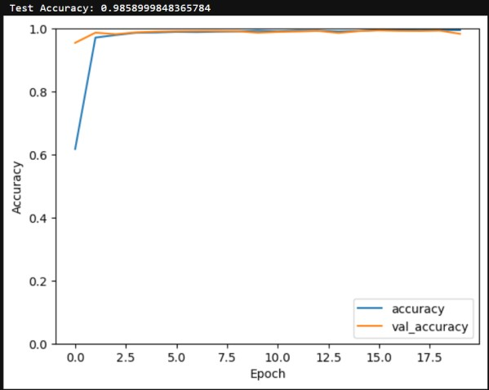 Fig 5. MNIST plot
The graphical representation for CIFAR is presented below.

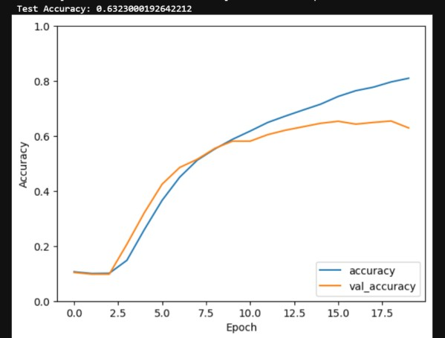
Fig 5. CIFAR plot

B. VGG-16:
Using the adam optimiser, the model performed very well on the MNIST dataset but was suboptimal on the CIFAR10 dataset.

TABLE I: VGG-16 model Results

 | Model |  | Adam  Model  Accuracy |  | Adam  Time/step
 | MNIST |  | 99.0% |  | 390ms/step
CIFAR10 |  | 73.00% |  | 546ms/step

The plot illustrates the relationship between model test accuracy and the validation accuracy for the MNIST dataset, offering insights into both the effectiveness and efficiency of the model.

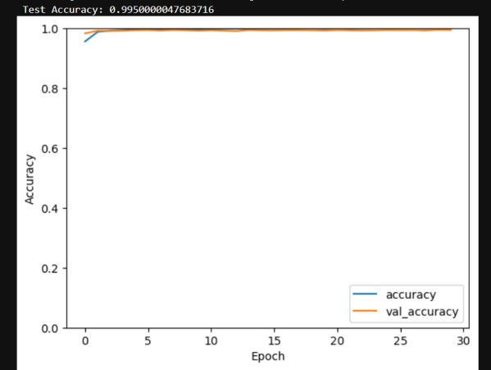
Fig 7. Plot for MNIST

The below graph represents CIFAR datasets.

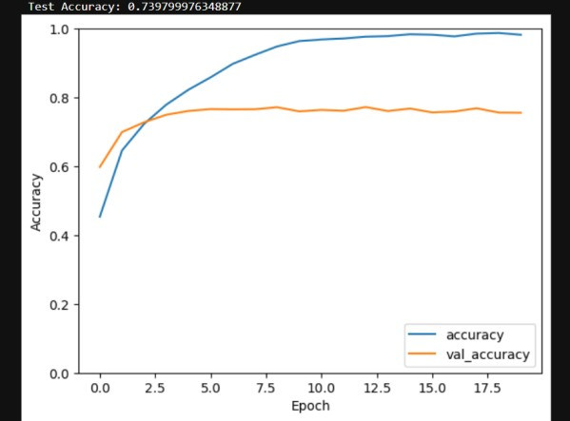
Fig 8. Plot for CIFAR

VI. CONCLUSION
In conclusion, the comparative evaluation of the VGG16 and GoogLeNet models on the MNIST and CIFAR datasets underscores their efficacy in the classification tasks. VGG16, characterized by its deep architecture and utilization of smaller convolutional filters, exhibits robust performance with a validation accuracy of 99.04% in MNIST and 73.00% in the CIFAR datasets. Conversely, GoogLeNet, distinguished by its innovative inception modules and global average pooling, achieves a slightly lower accuracy of 98.05% in MNIST and 00.00% in
CIFAR. Despite this variance, both models demonstrate remarkable accuracy rates, showcasing their suitability for image classification tasks. Moreover, the computational efficiency of each model, as evidenced by the training time per step, contributes to their practical utility in real-world applications. These findings underscore the versatility and effectiveness of deep convolutional neural networks in addressing complex image recognition challenges.

REFERENCES
- Simonyan, Karen, and Andrew Zisserman. "Very deep convolutional networks for large-scale image recognition." arXiv preprint arXiv:1409.1556 (2014).
- Szegedy, Christian, et al. "Going deeper with convolutions." Proceedings of the IEEE conference on computer vision and pattern recognition. 2015.
- Krizhevsky, Alex, and Geoffrey Hinton. "Learning multiple layers of features from tiny images." (2009): 7.
- Alex, Krizhevsky. "Learning multiple layers of features from tiny images." https://www. cs. toronto. edu/kriz/learning-features-2009-TR. pdf (2009).
- Krizhevsky, Alex, and Geoffrey Hinton. "Learning multiple layers of features from tiny images." (2009): 7.
- He, Kaiming, et al. "Deep residual learning for image recognition." Proceedings of the IEEE conference on computer vision and pattern recognition. 2016.
- Github: https://github.com/devasworski/Deeper-Networks-for-Image-
Classification/blob/main/GoogleNet.ipynb

